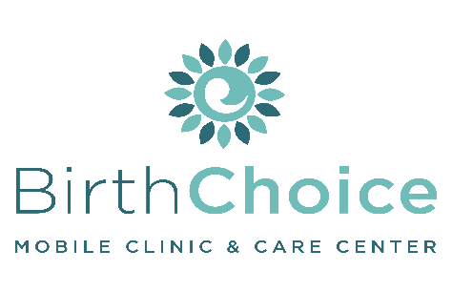

Job Description: Sexual Integrity Facilitator
For: ______________________________________
Dept: Client Services
Reports To: Client Services Manager
FSLA Status:
______________________________________________________________________________
QUALIFICATIONS:
- Express full agreement with Birth Choice’s (BC) Statement of Faith, Purpose Statement and Statement of Commitment
- Exercise Matthew 18 principals and follows the personnel handbook
- Is dependable, stable, and capable of following through on commitments
- Maintains a consistent life-affirming philosophy and would never refer or advise a student to have an abortion or use contraceptives, emphasizing abstinence as the only 100% effective way to avoid pregnancy or avoid contracting an STD.
- Has a sincere desire to reach young adults facing challenging decisions regarding their sexuality
- Completion of applicable training

SKILLS:
Basic use of technology (Word, PowerPoint)
- Effective communication & listening skills
- Time management
- Attention to detail
- Team player
- Able to relate with younger generation
- Spanish-speaking (*preferred but not required)

RESPONSIBILITIES:
The Sexual Integrity Facilitator will provide evidence-based education to the attendees regarding sexual health. The Facilitator works alongside other personnel in the program under the direction of the Client Services Manager. Each appointment is based on individual need.
- Provide education and support in a pleasant and non-judgmental manner.
- Reinforce the humanity of the unborn child throughout the program.
- Provide education and information in the areas of: sexual health, abstinence, contraception, STDs, menstruation/puberty, social media/dating, pornography/masturbation, pregnancy, fetal development and abortion.
- Discuss their spiritual relationships, encouraging them to seek an active relationship with Jesus Christ and get involved with a church.
- All information is to be kept confidential, except if reporting laws apply or if we believe or hear that a student is in danger of hurting themselves or others.
- Actively participate in continuing self-education (ie. review brochures/online resources etc.) to increase knowledge of teaching topics and material.
________________________________ __________________________________ ___________________
Printed Name Signature Date
Updated Sept. 2020

