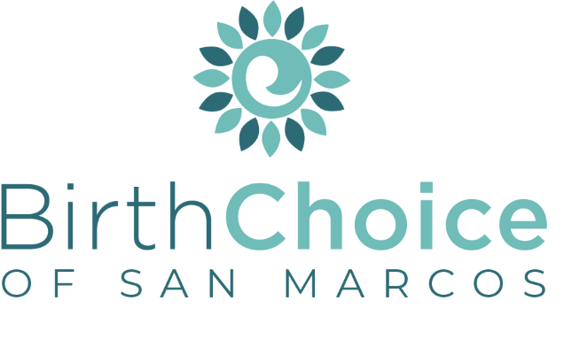
Job Description: Earn While You Learn Parent Mentor
For: ______________________________________
Dept: Client Services
Reports To: Client Services Manager
FSLA Status:
______________________________________________________________________________
QUALIFICATIONS:
- Express full agreement with Birth Choice’s (BC) Statement of Faith, Purpose Statement and Statement of Commitment
- Exercise Matthew 18 principals and follow the personnel handbook
- Is dependable, stable, and capable of following through on commitments
- Maintains a consistent life-affirming philosophy and would never refer or advise a client to have an abortion or refer for Birth Control
- Completion of applicable training
SKILLS:
- Basic use of technology
- Effective communication & listening skills
- Time management
- Attention to detail
- Team player
RESPONSIBILITIES:
The Earn While You Learn Parent Mentor at Birth Choice is responsible for the education, emotional support, and assistance of the women and men in the Earn While You Learn Bright Course program.
- Be fully prepared prior to the client's appointments.
- Provide emotional support in a pleasant and non-judgmental tone. Maintain a pleasant and courteous voice with clients.
- Review lesson plan to ensure client understanding and life integration.
- Answer questions covering any specific challenges or needs the client may be facing.
- Communicate with the woman’s client advocate to advise client advocate of how client is doing as well as passing along any information of any other needs they may have.
- Document effectively all correspondence with clients.
- Communication with clients through approved devices and software (Cool Focus, Teams, Outlook email)
- Hold all clients accountable to programs rules and guidelines.
- Pray with clients and discuss their spiritual relationships, encouraging them to seek an active relationship with Jesus Christ and get involved with a church.

_____________________________________ __________________________________ ____________
Printed Name Signature Date

Updated Feb. 2022

